Gwasanaeth Nyrsio Ysgolion
Cyf / 04 / rhiant / 09/23
Cod QR Gwefan Nyrsio Ysgolion
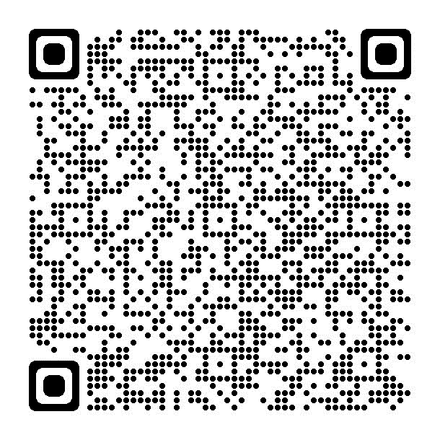
Annwyl Riant / Gwarcheidwad,

Mae'r Gwasanaeth Nyrsio Ysgolion yn ymwybodol bod eich plentyn wedi dechrau yn nosbarth derbyn yn yr ysgol hon yn ddiweddar a hoffem gyflwyno ein hunain i chi.
Nod y Gwasanaeth Nyrsio Ysgolion yw hybu iechyd y boblogaeth oedran ysgol ac yn sicrhau bod cymorth, cyngor a chefnogaeth ar gael i blant, rhieni, gwarcheidwaid a gofalwyr.
Pan fyddant yn mynd i mewn i'r dosbarth derbyn, caiff gofal eich plentyn ei drosglwyddo o'r Ymwelydd Iechyd i'r Nyrs Ysgol. Mae gan bob ysgol fynediad i Nyrs Ysgol. Nod Nyrs yr Ysgol yw hysbysu, addysgu a chefnogi plant a phobl ifanc i wneud dewisiadau ffordd iach o fyw i'w galluogi i ddod yn oedolion iach.
Mae gwefan Y Gwasanath Nyrsio Ysgol (Gwelir y cod QR) a’r pecyn croeso ar gael i chi ar wefan ysgol eich plentyn ac fe'u darperir y gwybodath cyswllt isod.
Bydd aelod o’r tîm Nyrsio Ysgolion yn mynychu ysgol eich plentyn yn ystod y flwyddyn academaidd hon i gynnal sgrinio rheolaidd ar gyfer taldra, pwysau a golwg plant dosbarth derbyn.

Byddwn yn cysylltu â chi os bydd unrhyw un o'r canlyniadau sgrinio yn adnabod unrhyw bryderon. Fodd bynnag, os hoffech wybod y canlyniadau sgrinio, cysylltwch â'r Nyrs Ysgol.

Os nad ydych yn dymuno i'ch plentyn gael eu taldra, pwysau a'u golwg wedi eu sgrinio gennym, rhaid i chi roi gwybod i'r Pennaeth yn ysgrifenedig ar unwaith.

Os mai dyma'r achos, mae'n bwysig iawn eich bod yn gwneud trefniadau i'ch plentyn gael prawf golwg gydag Optometrydd (Optegydd) lleol, mae hwn yn wasanaeth am ddim i blant a chynghorir y dylai pob plentyn gael gwiriadau llygad rheolaidd gydag Optometrydd.

Hoffai'r Rhaglen Mesur Plant sy'n cael ei redeg gan Iechyd Cyhoeddus Cymru ddefnyddio'r mesuriadau Uchder a Phwysau i helpu i roi darlun o dwf plentyn yng Nghymru. Mae'r wybodaeth a ddefnyddir gan y Rhaglen Mesur Plant yn gwbl anhysbys. Mae rhagor o wybodaeth ar gael yn https://phw.nhs.wales/services-and-teams/child-measurement-programme/

Os nad ydych yn dymuno i'r mesuriadau gael eu defnyddio gan y Rhaglen Mesur Plant, rhaid i chi roi gwybod i'r Pennaeth yn ysgrifenedig ar unwaith.

Yr eiddoch yn gywir
Y Gwasanaeth Nyrsio Ysgolion

Ffoniwch y rhif canlynol er mwyn cysylltu efo y Nyrs ysgol : 01639 862801
E-bost: SBU.SchoolNursing@wales.nhs.uk

School Nursing Service
Ref/04/parent/09/23
QR code for School Nursing Website

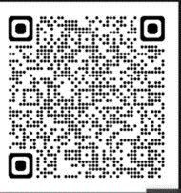
Dear Parent / Guardian,

The School Nursing Service is aware that your child has recently started in reception class at this school and we would like to introduce ourselves to you.
The School Nursing Service aims to promote the health of the school-aged population and ensures help, advice and support is available to children, parents, guardians and carers.
When they enter reception class the care of your child is transferred from the Health Visitor to the School Nurse. All schools have access to a named School Nurse. The School Nurse aims to inform, educate and support children and young people to make healthy lifestyle choices to enable them to become healthy adults.
The School Nursing Service website (via QR code), welcome pack and contact details is available for you on your child’s school website and they are provided below.
A member of the School Nursing team will be attending your child’s school during this academic year to carry out routine height, weight and vision screening for reception class children.

You will be contacted if any of the screening results identifies any concerns. If however you would like to know the screening results please contact the School Nursing Service.

If you do not wish your child to have their height, weight and vision screened by the School Nursing Team you must inform the Head Teacher in writing immediately.

If this is the case, it is very important that you make arrangements for your child to have a vision test with a local Optometrist (Optician) this is a free service for children and it is advised that all children should receive regular eye checks with an Optometrist.

The Child Measurement Programme run by Public Health Wales would like to use the Height and Weight measurements to help give a picture of child growth in Wales. The information used by the Child Measurement Programme is completely anonymous. More information is available at https://phw.nhs.wales/services-and-teams/child-measurement-programme/

If you do not wish the measurements to be used by the Child Measurement Programme you must inform the Head Teacher in writing immediately.

Yours Sincerely
School Nursing Service
To contact the School Nurse please ring 01639 862801
E-mail SBU.SchoolNursing@wales.nhs.uk

